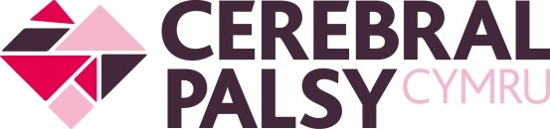**Title of Role:**  Facilities volunteer

**Hours:** Flexible (1-2 hrs a week)

**Location:** Cerebral Palsy Cymru Children’s Centre, Llanishen

**Reports to:** Operations Manager

**Role outline:** As facilities volunteer, you will be responsible for helping maintain Cerebral Palsy Cymru’s therapy centre. This will involve carrying out health and safety checks, checking stock levels, ensuring cleanliness and tidiness of the centre, and supporting the therapy and administrative staff in maintaining a happy and healthy therapy environment.

**Duties & responsibilities:**

* Carry out safety checks around the children’s centre, including fire safety and water checks.
* Organising and removing recycling.
* Maintaining travel bags for our community outreach.
* General housekeeping.
* Gardening around the centre, including maintaining tidiness of car park and children’s garden.

**Person specification:**

* A passion for the charity's mission, a desire to make a positive impact and commitment to Cerebral Palsy Cymru’s values, purpose, and environment.
* Reliable, punctual, and responsible.
* Ability to work independently.
* Willingness to learn and adapt to new tasks.
* Self-motivated; able to work with the minimum of supervision.
* A can-do attitude; positive team player.
* Basic knowledge of health and safety standards is desirable but not essential.

**Benefits:**

* Training in basic health & safety principles.
* Contribute to a meaningful cause and make a difference in the community.
* Become part of a supportive and friendly volunteer community.
* References and recognition for your volunteer work after three months of volunteering.
* Tempo Time Credits.

**How to apply:**

If you are interested in becoming a Volunteer at Cerebral Palsy Cymru, please contact the volunteering team at [volunteering@cerebralpalsycymru.org](mailto:volunteering@cerebralpalsycymru.org) to request an application form.

We welcome Welsh-speakers and applications in Welsh.

**Please be aware: Volunteers in our children’s centre are required to undergo a basic DBS check, which will be organised by the Charity.**